Creating Job Templates
Objective
After completing this lesson, you will be able to manage job templates to streamline the job creation process and maintain consistent job postings.
Job Templates in SmartRecruiters
Job templates in SmartRecruiters are powerful tools for streamlining the job creation process and ensuring consistency across your job postings. By leveraging templates, you can significantly reduce the time it takes to create a job advert and maintain a standard brand message.
Benefits of Using Job Templates
- Efficiency: Templates save time by pre-populating key sections, such as company description and standard job descriptions, and the four job fields used for job board mapping (Industry, Function, Experience Level, and Type of Employment).
- Consistency: Templates ensure that all job postings adhere to a standardized format and include consistent information, reflecting a professional brand image.
It's beneficial to have at least a default template that populates your company's description, even if specific job descriptions and qualifications vary. This ensures a consistent starting point for all job creations.
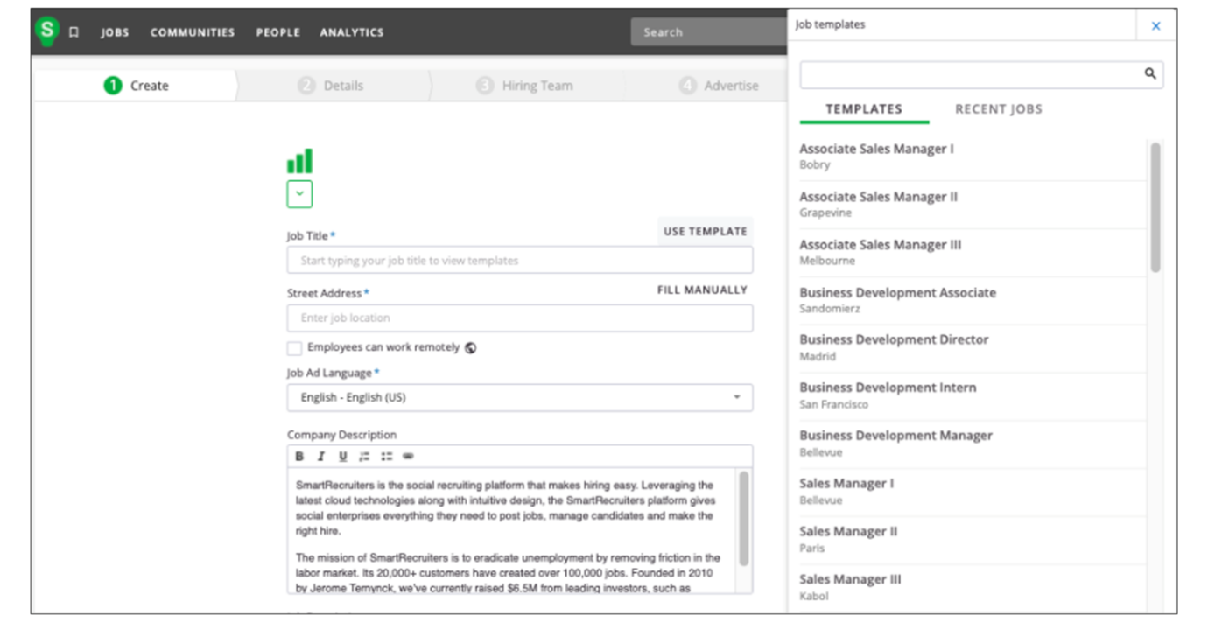
Information Stored in Templates
Job templates are centrally created and managed within the Jobs tab, where you can create a template in the same way as a new job is created. The following information can be saved within a job template:
- Job Title and Job Ad Language
- Company Description, Job Description, and Qualifications
- Videos and Additional Information
- The four fields used for Job Board mapping: Industry, Function, Experience Level, and Type of Employment
User Access and Management
- Only users with Administrator or Extended default system roles can create job templates.
- There is currently no separate template library; templates are managed directly within the Jobs list.
- Using clear naming conventions (e.g., UK Template - Account Manager) is essential for easy maintenance and to help the system suggest templates to users.
Create a Job Template
Creating a job template follows the same steps as creating a new job:
Steps
- Navigate to the Jobs tab and select Create Job or use the quick action in the main header.
- Enter the job information you want to pre-populate, such as Company Description.
- Provide general guidelines if you prefer not to include specific text for fields like the Job Description, Qualifications, and Additional Information.
Note
For a better candidate experience, you can limit the number of bullet points or provide a structure for recruiters to follow, such as Add Text.
- Assign a clear and descriptive title. The system uses this title to suggest templates to users as they type.
- Select the Save this as a template checkbox.
- Select Next.
- Complete the required fields within the Add More Details page.
Note
All fields except the four standard fields: Industry, Function, Experience Level, and Type of Employment will not populate.
- Select Next.
- Add the Hiring Team information, including yourself as a user.
- Enter a Target Start Date (this is for informational purposes only and is not retrieved when the template is applied).
- Select Save.
Use a Job Template to Create a Job
Once a template is created, you can utilize it to quickly generate new requisitions.
Steps
- Type in the job title.
- Select the desired template from the Use a Template section of the dropdown list.
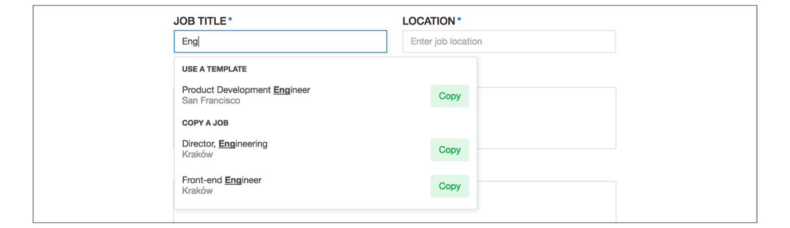
- Access more options if needed by selecting the Use Template button on the top right of the job title field or the See More button at the bottom of the search dropdown.
- Update the job title once the template is applied to ensure it is specific to the new opening.
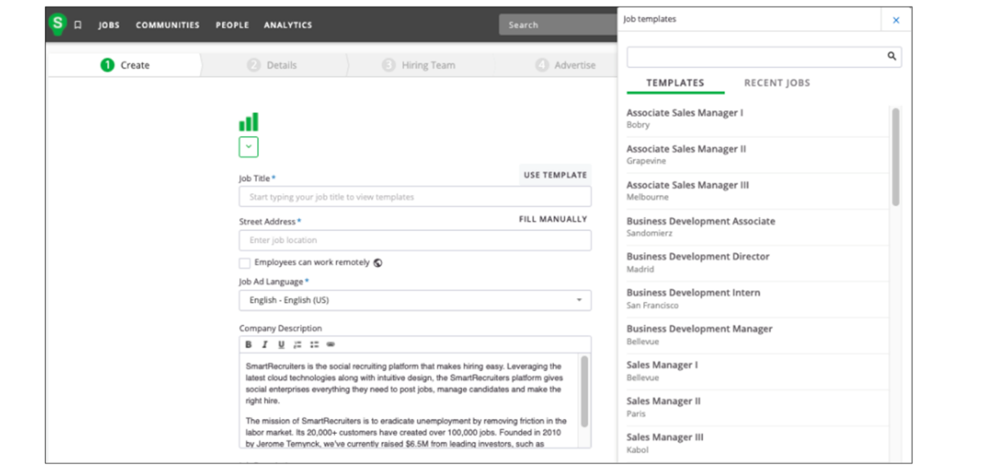
Modify an Existing Job Template
You can update template content to ensure future postings reflect the latest information.
Steps
- Go to the Jobs list.
- Search for the job template by its name.
- Navigate to the Job Ad tab.
- Select Edit to update the content or settings.
Note
Important Governance Rule: Editing a template does not retroactively update jobs previously created with that template. Changes only apply to new jobs created after the update.
Watch the video below for more information about creating job templates.
This video is for demonstration purposes. Any references made in this video to previous or later videos in this course (including titles, numbers, links, or sequence) may differ from the current course structure. Additionally, some functionalities shown may have evolved over time due to ongoing enhancements or business decisions.
Add an Interview Scorecard to a Template
Adding scorecards to a template ensures specific evaluation criteria are automatically assigned to new jobs.
Steps
- Access the job template via the Jobs tab.
- Open the template and make any necessary changes to the job ad or job details information.
- Add an Interview Scorecard by selecting the Hiring Process tab.
- Scroll to the Interview Scorecard section.
- Use the Add interview criteria bar to search for and add specific competencies or skills.
- Add optional descriptions for the criteria if necessary.
- Select Add.
Note
Scorecards can be added to jobs through both organization field settings and job templates. When both are configured, scorecard criteria may be applied from multiple sources.
Summary
- Job templates in SmartRecruiters streamline job creation by pre-populating key fields, saving time and effort.
- Templates ensure consistency in job postings and maintain a professional brand image.
- Users with an administrator or extended role can create and edit job templates within the Create Job area.
- Templates can be easily found and used when creating new jobs, and they can be further customized. Make sure that you use a naming convention when creating a job template.
Hi, in this video, we're going to take a look at job templates
in SmartRecruiters. So as a user, when I
create a job, one of the features available to
me is to use a template. Obviously, the benefits of this
are that it makes it much easier for the user to complete a job
advert, and also that it can help us to drive consistency in the way
we're advertising our jobs in the system. So I can select the use
template option here. I can grab one of the templates. So I'm going
to select this one and I'll see that that then populates the company
description and job description for me. I can see it's also populated
qualifications and additional information. I can still come
through and edit these and add additional information as needed.
But obviously it's giving me a great starting point to be able to go
ahead and create my job advert. It's definitely beneficial to have
at least a default template available in the system that populates your
company description, for example. So whilst you might not have
all of the job descriptions and qualifications needed for your individual
jobs, any consistent information that you have, if you create a
default template, you can at least have that as the starting point for
all job creation. To actually go ahead and create a template, we
still do this in the create job area. And job templates can be created by
users who have one of the standard roles of either administrator
or extended in the system. The information that will actually be
saved on the job template is all the information we can see through
here. So the company description, the job description, qualifications,
additional information and the videos along with the job title.
So I can then come in and say, OK, so this is going to be my UK
template for an account manager, and we just want to make these
template titles something that makes it easy for our users
to select from. Also when you are creating a job in the system
and you start to type in the job title field it will also
prompt you with templates that are a suitable match so the
naming convention is very important here especially if
you're going to have a lot of them. Street address so I do have to put
in an address for my job template although it won't actually be copied
through when a user creates a job because of course they could be
creating that job in many different locations it is a required field to
be able to go ahead and create this. So I can then come in and add in
the information that I'd like to be saved on the template so my company
description I've already got that there. I can then come in and obviously
add probably a bit more detail than here but it could be that if
you know you don't have all of this information right now, you just want
a template that pulls in the company description and then some guidelines
as to where they can get their job description or the type of
information you would like them to add here. As I mentioned you can also add
your additional information and any videos and then the important step
here is to select this box 'Save this as a template'. I'm then going
to go ahead to the next step. Again I'm going going to have to fill in
the required fields here, but these job detail fields will not pull
through to the template itself, because again, these could vary depending
on where the job is being created. The only information that we'll
pull across are our standard fields at the bottom here, so
we can make sure that these are correct, but of course,
again, the user can edit those if it's different for the job
they're actually advertising. I'm then going to go ahead to the
next step, and again, I'm going to need to add the minimum required
information. So I will need to add a recruiter or hiring manager
or executive here. I'll need to add a target start date. But again,
this information will not be pulled through to a job when a user
creates it from a template. And then at this step, I'm just going to
go ahead and save. I don't need to publish it. I don't need to send
it for approvals. If approvals are turned on, I just need to save
this. Once I go through to look at the job, I can at any point come
through to my template and make edits in the future. So this is how I
can come and edit a template so I can make updates to my job advert.
I can also add here my interview scorecard. So in our earlier video,
we saw how we can have criteria automatically assigned to a job
based on particular org fields in the job. If I want to come in
and say, well, actually for these account manager jobs, I also want
to add in these particular criteria, I can go ahead and add the
criteria in. And then when a user uses this template to create
a job in the future, these additional criteria will
automatically be pulled in for them. So I've now created my template. You'll find your templates on the
jobs list, so the same as you would find any other jobs. So you could
search perhaps by template or the naming convention that you've used
to narrow down and look for just templates you've created in the
system. And then, of course, when I go to create a job in the future, I
will now be able to see that template is available for me down here so
that's the one I've just created and of course if I start to type in
the job title list the system will then prompt me with those matches as
well. Obviously the key point here when we train our users how to use
job templates is that they just make sure they remove this template
wording from the job title before they go ahead and publish their job
and that's how we can use our job templates in SmartRecruiters and
how we can create them. Thank you.
Creating Job and Organization Fields
Objective
After completing this lesson, you will be able to create job and organization fields to support consistent job setup and automated hiring processes.
Job and Organization Field Types
The Job and Organization (Org) fields are the key to customizing the details of your jobs and configuring templates, approvals, screening questions, and other tools available for individual jobs or groups of jobs.
Job Fields
Job fields are customizable fields that appear on every job posting. Some standard fields, such as the EEO field (required for U.S.-based positions) and job board mapping fields, are included by default. In addition, you can create and customize extra job fields to meet your organization’s specific needs.
Job fields are useful for:
- Capturing job-specific information for reporting, compliance, and analytics.
- Adding parameterized information as merge fields in offer letter templates. Each job field is automatically available as a merge field for offer templates, but not for email templates.
Examples of job fields:
- Specific Project Code
- Required Travel Percentage
- Security Clearance Level
- Internal Compensation Band tied to a specific vacancy
These fields are managed and populated within the Job Details tab of a requisition.
Org Fields
Organizational (Org) fields are a special type of job field that drives configurations and processes within SmartRecruiters. They are used to capture information related to the company's organizational structure and are applied consistently across all or most job requisitions. They provide the necessary dimensions for filtering, grouping, and analyzing recruiting data based on the company's internal hierarchy. As with job fields, org fields are also reportable.
The use of org fields enables automatic association of different hiring processes, job & offer approvals, email templates, scorecards, or screening question sets based on specific job criteria. For example, if you select Sales as the department (an org field), you can automatically apply hiring processes specifically for sales jobs. Regular job fields do not have this capability.
Examples of Org fields:
- Business Unit
- Division
- Region
- A specific Cost Center that all jobs within that organizational structure must belong to.
These fields are typically managed and kept consistent by system administrators, ensuring reliable segmentation in analytics across the entire enterprise.
Three standard Org fields that will appear by default:
- Brands: Set up on the Brands page.
- Country: Choose for each job when the job is created.
- Department: Set up on the Job Fields page. If this field is used, it will appear as a filter on the SmartRecruiters career site. It is recommended to use values that are meaningful to candidates, such as job families.
Field Dependencies
You can set up dependencies so that a selection in one field (e.g., Research and Development) automatically populates another (e.g., Engineering as the Cost Center).
Org Fields can be used to configure these features:
- Hiring processes
- Application fields
- Job Approvals
- Offer Approvals
- Screening Questions
- Auto Replies
- Email Templates
- Access Groups
- Offer Templates
- Scorecard Criteria
- Career Pages
- Job Footers
- Application experience
System Limits and Restrictions
Creating custom Job or Org Fields in SmartRecruiters lets you tailor the platform to your unique processes and capture the specific data needed for more effective, accurate recruitment workflows.
You can create up to 200 Job fields, including both active and inactive fields. In addition, you can create a maximum of 22 custom Org fields, not counting the standard fields: Brand, Department, and Country.
Add a Job or Org Field
Steps
- As an Admin, select your User icon; select Settings / Admin.
- Select Job Fields under the Configuration section.
Note
On the Job Fields interface, you can view, edit, add dependencies, activate, and reorder the job fields created for the system. The order in which they are listed is the order that they will appear to the user during the job creation process.
- Select the Add Field button.
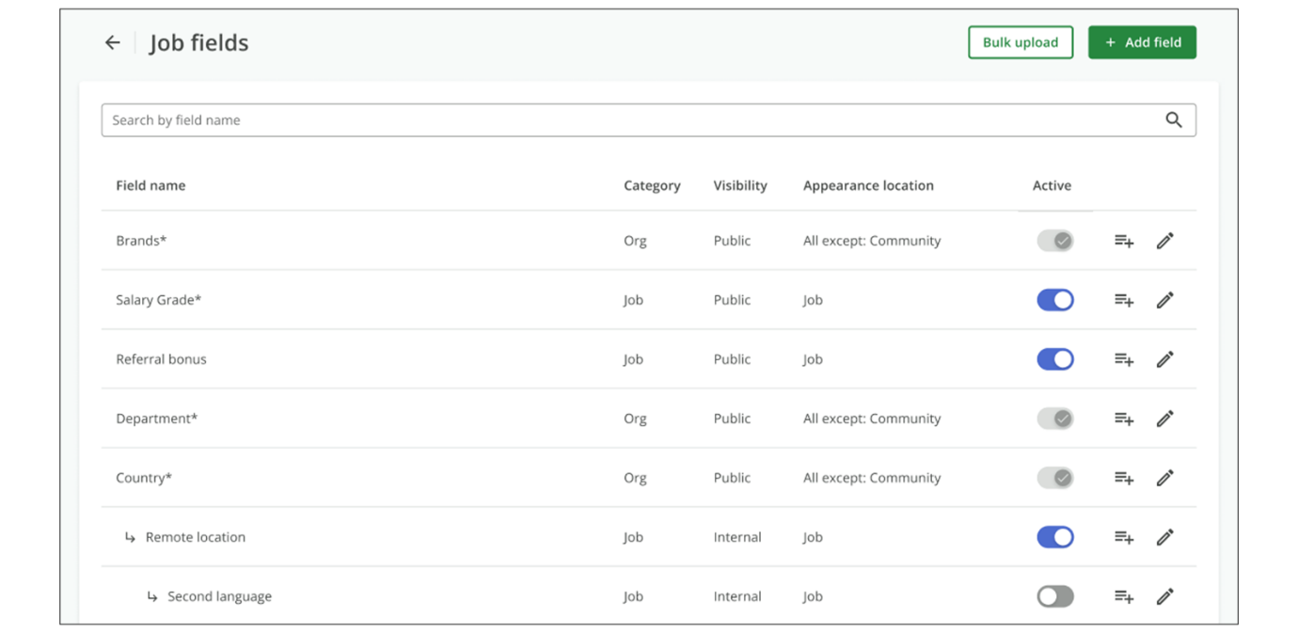
- Select the desired Field Type (single select or free text) from the dropdown menu.
Note
Once the job or org field is created, it cannot be deleted. Once the type of the field is selected, it cannot be changed.
- Provide the following information for the new field:
  - Name: The name of the field (up to 200 characters).
Note
The default Job/Org fields name (Brands, Country and Department) will be automatically translated as per the user's language. Custom Job/Org fields will NOT be automatically translated. The API can be used to translate the name and values.
  - Field Category: Choose between a regular Job Field or an Org field.
  - Type: Select the field type. Org fields can only be single select, as their values drive other processes. Changing the type to free text will automatically convert the field to a regular job field type.
  - Visibility: Choose Internal (visible only to specific roles) or Public (visible on career sites and available via API).
  - Required field: Indicate whether the field is required.
  - Where does this field appear?: Choose where the field should appear, such as on the job posting, in the Communities configuration, on the job approval, or on the job ad. When displayed on the job ad, both the field and its value are visible to the candidate. This option is available only for dropdown fields.
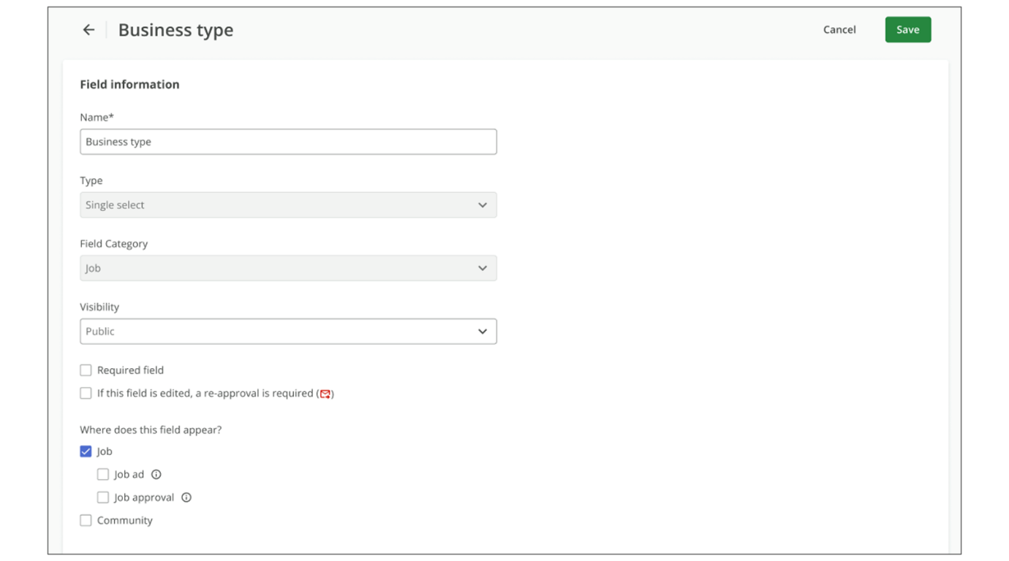
- Select Save to finalize and activate the new custom job field. It will now be available in the Job Details tab for both new and existing job requisitions.
Add Field Values Manually
New fields are not active until you add at least one value.
Note
All fields can have unlimited values, except for Brands and Departments. Brands are limited to 2,000 values, and Departments are limited to 20,000 values. Each individual value name can be up to 200 characters long.
Steps
- Enter the desired value in the field.
- Identify the Pending new status, which indicates the value is added but not yet saved.
- Select Save at the top of the page to finalize all pending values.
Add Field Values in Bulk
Steps
- Select CSV upload to upload multiple values in a CSV file.
- Choose a CSV file from your computer that contains a simple list of values with no headers.
Note
You can process up to 2,000 values per session, whether added through the UI or uploaded via one or more CSV files. For larger volumes, save changes every 2,000 values or use the bulk management feature.
Job or Org Field Sorting
After a job or org field is created, administrators can reorder fields by dragging them up or down. Fields can be moved individually or together with their dependent fields.
The order you set determines how fields appear on pages, such as the Job Details tab (if the field is visible there).
Parent and child fields cannot be reordered across levels. A child field cannot be moved to the parent level. You can only change the order within the same level. To change parent-child relationships, you must update the field dependencies.
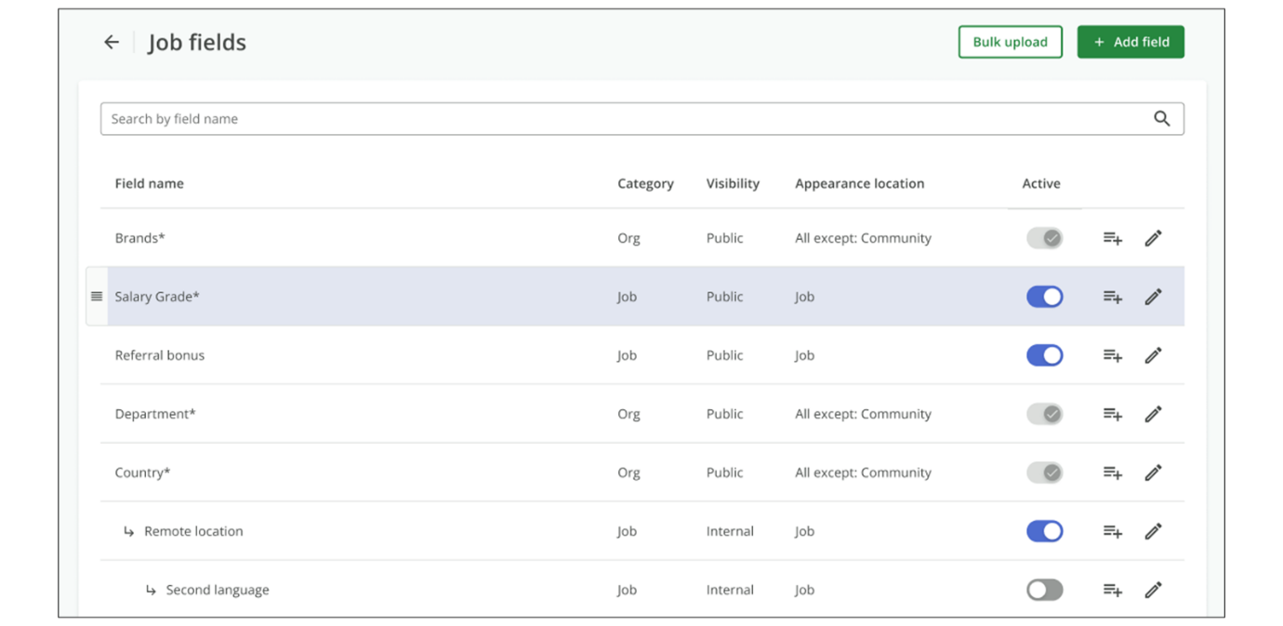
Watch this video for more information about creating job and org fields.
This video is for demonstration purposes. Any references made in this video to previous or later videos in this course (including titles, numbers, links, or sequence) may differ from the current course structure. Additionally, some functionalities shown may have evolved over time due to ongoing enhancements or business decisions.
Summary
- Job fields allow customization of job postings, capturing specific details about each role, while org fields drive configurations and processes within SmartRecruiters.
- Administrators can create job fields by navigating to Settings / Admin, then add a new field and configure its name, category (job or org), type (single select or free text), and visibility (internal or public).
- Organizational (Org) fields are a special type of job field that drives configurations and processes within SmartRecruiters. The use of org fields enables automatic association of different hiring processes, job & offer approvals, email templates, scorecards, or screening question sets based on specific job criteria.
Hi, in this video we're going to look at how to create and use job and org fields. The job fields that we're going
to be looking at today are the ones that appear on the second
page of the job creation process. There are some job fields here
that will show up on every job, including the EEO field, which does
show up on all jobs that are posted for the United States, and then
the four fields at the bottom, these are used for job board
mapping purposes. But all the fields above the EEO field are job fields
that you can add and customize. You'll notice that some fields are
required, which means that field has to be completed in order to keep
moving in the job creation process. And some job fields have dependencies. We will look more at dependencies
in another video, but when I say dependencies, what I mean
is that depending on what you choose for a certain field,
other fields will populate. For example, when I chose R&D as a
department for this job, you'll see the cost center field showed up
with the value of engineering, but if I were to change the
department to customer service, now you'll see the cost center
value change to customer success. Dependencies can help users by
saving time and allowing them to not have to scroll through
several values in a field, and admins can configure dependencies
when creating job fields. To create a job field, click Settings
and Admin, and then Job Fields. Here you'll see a list of all of your job fields, both active and inactive. The order that the job
fields fall on this page is the order that
they'll fall on a job. So if you need to, you can
drag and drop different fields to move them
into a different order. There are three standard job fields
that come with SmartRecruiters. Brands, and you can edit
brands in the Brands section of the Settings and Admin page. You can learn more about editing
brands in our Brands tutorial. We also have Country as a standard
field, and you'll notice Country is not editable because it is
just a standard list of countries. And then Department. Department is editable in
that you can add your own department values here,
but you can't change the type, category, or visibility
of the department field. You'll notice that some
fields are called org fields. An org field is a special type
of job field that is used to drive configurations and
processes within SmartRecruiters. For example, you can set up
different hiring processes or screening question sets
based on certain job criteria. So in this case, since
department is an org field, I can use this field to dictate what
hiring process or screening questions will be applied to
this job after it's created. So for the job I'm creating
I choose the department as sales. I can then have
hiring processes I've created for just sales jobs
to be applied to this job. Regular job fields do not have this
ability and you cannot configure other processes based on that
field. You can create regular job fields to collect information
that you would like to report on. To add a field you click the Add
Field button, and then give your field a name and then you choose
the category, meaning is this going to be a regular job field or an
org field. I want to note that with job fields and org fields there
is a limited amount that you can have in your system. So for regular
job fields you can create up to 200 fields and that is inclusive
of both active and inactive fields. For org fields you can create
up to 22 additional org fields and again that is inclusive of
both active and inactive fields. So as you're creating your
fields make sure to really think about is this field a field that
i want to drive process within my system. For this scenario i'm
going to leave this as a job field and not an org field. You
can also choose the type of field so you can have a single select
field or a free text field. If this was an org field you
can only have single select as an option, since the value
of an org field drives other processes in the system. So
if I were to change this to free text, you'll notice it
changes it back to a job field. And then you can choose the visibility. Internal visibility can be used if
this field is really only going to be used for internal categorization,
or if you don't want this field to be seen by every role, as only certain
roles can see internal job fields. Public visibility means that this
job field can be seen by more roles in the system but also it
can be found by the job posting API and can be used to determine
configuration of career sites. In this scenario I'm going to
leave this as a public field. You can decide whether your field
is required and then you can decide where this field is going
to appear. I do want this field to appear on the job, and if I have
the CRM functionality I can choose to have it show up in the CRM
as well, and I can also choose to have this field show up on both
the job ad and the job approval. And if you chose single select as your
type, this is where you're going to add your values. You can simply
just start typing your values and if you have a long list
of values and you don't want to hand type them, you can
upload a CSV of your values. They would just have to be in
one column with no headers. You can also choose the sort of
your values in the drop-down. You can drag and drop your values
if you want to create your own custom sort or you can have them
sort alphabetically. And then you can have the order number
display in the drop-down as well. Before I save my field I also want
to note that once you've saved your field you cannot change the
field category or the type. So make sure everything is set how you want
it before you click create field. In this case I think I'm good to go, so I'm going to click create field. You'll see my field here, contract type. The category is a job, it's public,
I don't have any dependencies yet. And when you do create a new
job field, you do have to make sure you mark it as active so
it will show up on the job. So now if I go to create a job, you'll now see contract type here. Thank you for watching this video
on creating job and org fields.

Creating Job Field Dependencies
Objective
After completing this lesson, you will be able to configure job field dependencies to streamline job creation and reduce errors.
Field Dependencies and Relationships
Job field dependencies in SmartRecruiters allow you to create relationships between job and organization fields, where the visibility or available options in one field (the child field) are determined by the value selected in another field (the parent field). This feature simplifies the job creation process by presenting users with only the relevant options, reducing the likelihood of errors and saving time.
When setting up dependencies, it's important to understand the parent-child relationship:
- A child field can only have one parent field. This means a field cannot be dependent on multiple other fields simultaneously.
- A parent field can have multiple child fields. One field can control the options available in several other fields.
- Child fields can also have their own child fields, creating a hierarchy of dependencies. This allows for complex and granular control over the job creation process.
Configuring Dependent Field Values
Once you have established the parent-child relationship, you need to configure which child values are dependent on which parent values. To do this, edit the child field and locate the Configure dependent fields section.
In this section, the parent values are listed on the left, and the child values are on the right. For each parent value, you can select which child values should be displayed when that parent value is chosen. If you need to add additional values to either the parent or child field, you can do so, but remember to save the field before configuring the dependencies for the new values.
Example: Contract Type and Type of Contract
Let's say you have a Contract Type field with options like Employee and Contractor. You can make the Type of Contract field dependent on the Contract Type field. If a user selects Employee for Contract Type, they might not need to see any options for Type of Contract. However, if they select Contractor, you can configure the Type of Contract field to display options like Freelance, Temporary, or Consultant.
Example: Office Location Dependencies
​Another practical example is setting up dependencies for office locations by country and state. You can have a Country field as the parent. Depending on the country selected (e.g., United States), a child field for Office Location US appears, listing the US states. Then, based on the state selected (e.g., Massachusetts), another child field for City appears, showing cities in that state (e.g., Boston, Worcester). For countries without states, you can create a separate Office Location Other field that appears when a country other than the US is selected.
Create a Dependent Field
Steps
- Navigate to Settings.
- Select Job Fields located in the Configuration list.
- Identify the field intended to be the Parent and select its Dependencies icon.
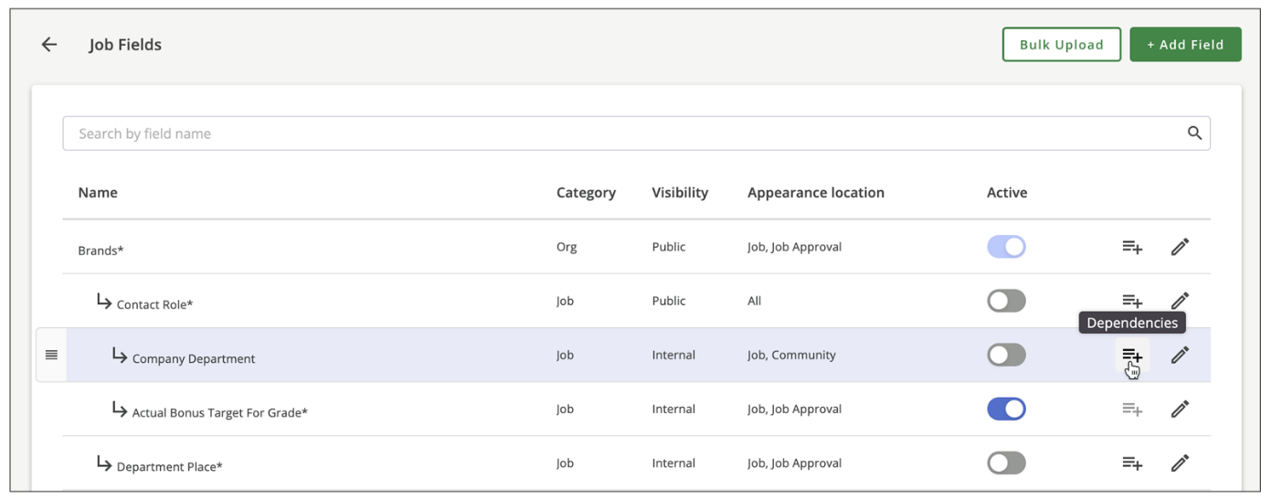
- Choose one or more children from the list of fields without parents.
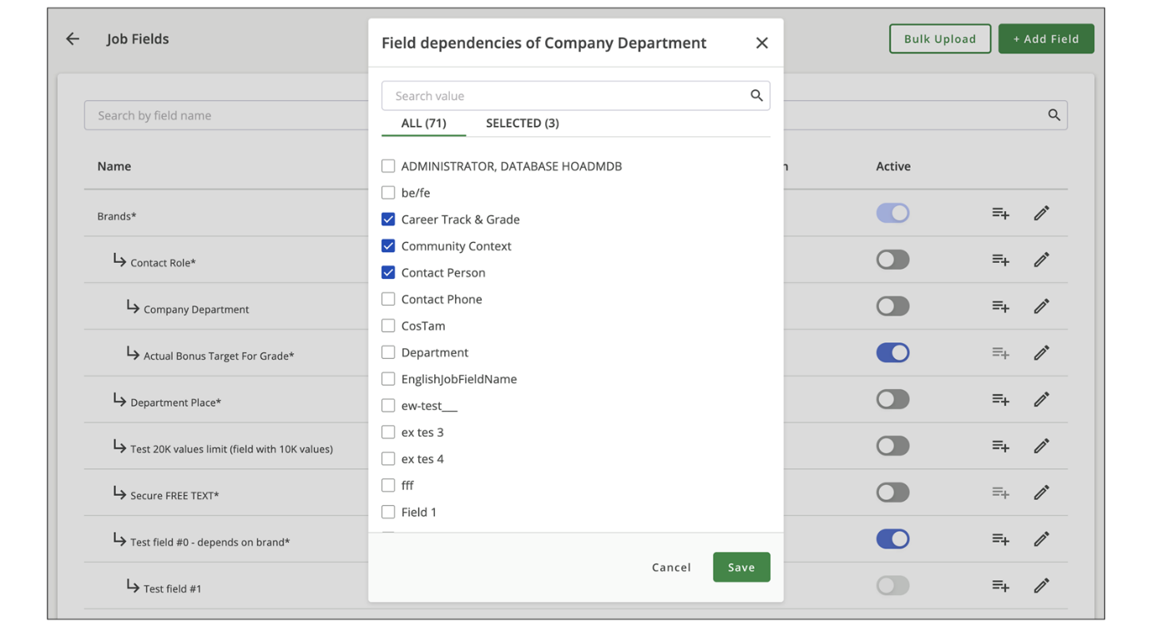
- Select Save.
- Repeat if you need to add more dependent fields to the Parent field.
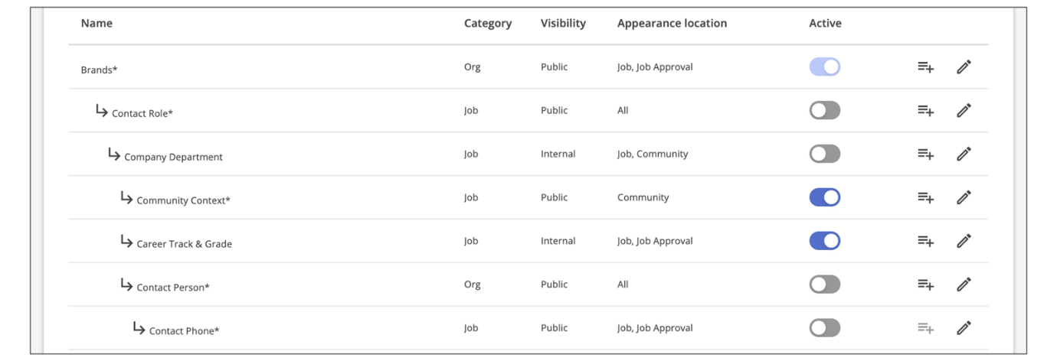
Set Value Dependencies
By default, only the child field is dependent, and all its values are available regardless of which parent value is selected. You can also set value-level dependencies so that the parent field’s selected value controls which specific values appear in the child field.
To set value dependencies:
Steps
- Select the Edit icon for the child field.
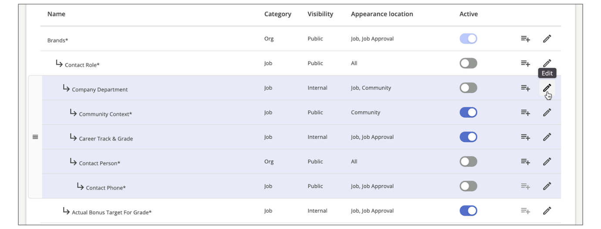
- Locate the Field dependencies section.
- Select a specific value for the parent.
- Select the corresponding child values that should be visible when that parent value is chosen.
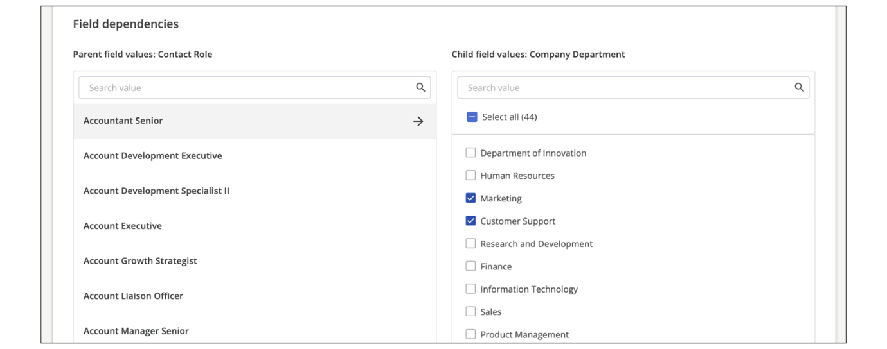
- Select Save.
Dependencies Testing
After configuring the dependencies, it's crucial to test them to ensure they work as expected. When creating a job, select different values for the parent field and verify that the correct child fields and values are displayed.
Watch this video for more information about creating job field dependencies.
This video is for demonstration purposes. Any references made in this video to previous or later videos in this course (including titles, numbers, links, or sequence) may differ from the current course structure. Additionally, some functionalities shown may have evolved over time due to ongoing enhancements or business decisions.
Summary
- Job field dependencies streamline job creation by showing relevant field values based on previous selections.
- A child field can have only one parent, but a parent field can have multiple children, forming a hierarchy.
- Configuration involves selecting parent and child fields, then specifying which child values appear for each parent value.
- Dependencies can be used for various scenarios, such as contract types or office locations, improving accuracy and efficiency.
- Testing is essential to ensure the dependencies function correctly and provide the intended user experience.
Hi, in this video we're going to be
looking at job field dependencies in SmartRecruiters. When creating
job and org fields you can make certain fields dependent of other
fields. Creating dependencies with job fields can significantly streamline
and cut down the time it takes to create a job by giving users the
ability to only see the field values that are relevant to the job that
they're creating. It also can help cut down on the amount of mistakes
made on a job when the incorrect information is selected for a job
field. So to create dependencies in job fields I'm on the job fields page
which you can find under the settings and admin page and I already have
a few dependencies created here. When creating dependent fields any
child field can only have one parent. So for example if I wanted region
to be dependent of country but I also maybe wanted to be dependent of
brand that won't work. It can only be a child to one field but a
parent field can have multiple child fields and even child fields can have
their own child fields to create a sort of hierarchy in the dependency.
So to create a dependent field you're going to choose the field that
is the parent and click on dependencies and here you're going to decide
what other field is going to be the child of contract type. So in
this situation depending on what they choose for a value under contract
type I want them to be able to see types of contract so I'm going to
use type of contract as the child. So now you can see type of contract
has become the child to contract type, and if I click Edit on the child
you'll see when I open up the field now there is a new section called
configure dependent fields. Here is where I'm going to decide what child
values are going to be dependent on the parent values. So the parent
values are on the left and then the child values are on the right. If
you need to add additional values, since I'm in the child field right
now. If you need to add additional values, maybe you're looking through
and you decided that you needed another value, you can do that here but
they won't appear in the dependent field area until you save. So you'll
have to save and then come back into the field and they'll appear here
and you'll be able to select them. So in this case for contract type,
if somebody selects employee, they don't need to see any additional
type of contract. But if they choose contractor, I want them to see all
of these, so I'm going to click select all, and so if somebody chooses
contractor as a value for contract type, they're going to be presented
with another field that have these values and they can choose
from. So I'm going to save. So now if I go to create a job and I'll quickly
just put in some details here. And I go to my next page
where I see contract type. Again, if I choose employee,
there's no dependent fields on that. I did not say that any child
fields would show up with employee. But if I choose contractor, now
you'll see the type of contract field has appeared and then I
can choose the type of contract. If I wanted to, I could have
a third level of dependency. So if I wanted another field
to appear, depending on what they chose in this
field, I can do that as well. Another example of how dependencies
can be used is depending on what country my job is in, I can have
certain fields populate when I get to that second page of the job creation
process. So how I have it set up now, if I want to look at office location,
I have an office location US field here and then a child of that
child which is the city. I also have office location other so I'll show
you what those look like. So office location U.S. is saying that if the
job is located in the United States I want these to appear.
Now if I looked in the UK you'll see none of these
are selected so this field won't show up unless the
job is in the United States. And then depending on what they
choose as the state for the U.S. If they choose New York they'll
see another field populate with the New York cities where
we have office locations, Massachusetts has the
Massachusetts cities, and so on. And then to account for the
office locations we have in other countries I just created a separate
field called office location other. And this is where we don't necessarily have states but if the job was in the UK, then they'll see a London office
location appear and same goes for Canada or India. So I'll show you what
that looks like. So we're going to create a job. And in this case I'm going
to have it be in the United States. And now you'll see that office
location US field appear. And since this is going to be in Boston, I'm going
to choose Massachusetts. And now I have the option of selecting our
Boston office or our Worcester office. Now if I go back and have
the job be in another country I'll say this is in Toronto now you'll see you don't see
the office location US field you only see the other field
and here it will give me the selection of Ottawa or Toronto.
Thank you for watching this tutorial on creating job field
dependencies in SmartRecruiters.

Managing Job Locations
Objective
After completing this lesson, you will be able to configure job location settings and predefined locations to ensure consistent and accurate job postings.
Job Location Management
When using SmartRecruiters, it is important to ensure consistency and accuracy in job postings across your organization. Managing job locations effectively streamlines the job creation process, reduces manual data entry, and improves the overall candidate experience.
SmartRecruiters offers flexible options for managing job locations, allowing administrators to control how locations are added during the job creation process. To manage the available location options, open Locations Management in Settings.
There are three primary options for capturing this data:
- Input street address: Captures the full address and displays the specific location on Google Maps for candidates.
- Input city: Uses job location city and Google API; used when an exact address is not required or varies by role.
- Select predefined location: Administrators manage a set list of locations for users to select, ensuring job location consistency.
Note
Customers can select the job location option during job creation from the Settings tab in Locations Management. This is a global setting for the entire instance and applies to all jobs.
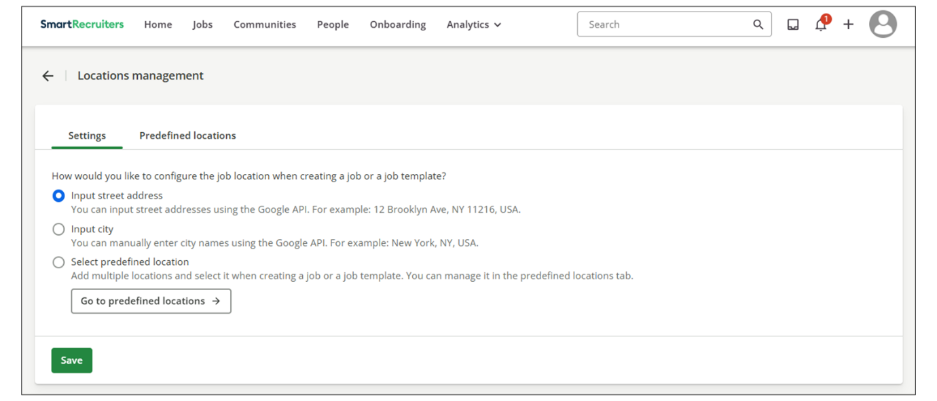
Configure Job Location Settings
Steps
- Navigate to Settings.
- Select the Locations Management option within the Administration section.
- Select the checkbox next to the preferred location option (Street address, City & Google API, or Predefined location).
- Select Save.
Predefined Locations
When enabling predefined locations, the system allows administrators to create a centralized, approved list of locations that hiring teams must use when generating a new job. This ensures that only standardized location data is used, promoting uniform reporting and a clean candidate experience.
Predefined locations can be created and managed on the Locations Management page in Settings. When predefined locations are enabled in the system, a separate tab will appear within Locations Management to manage these settings. Within this tab, new predefined locations can be created.
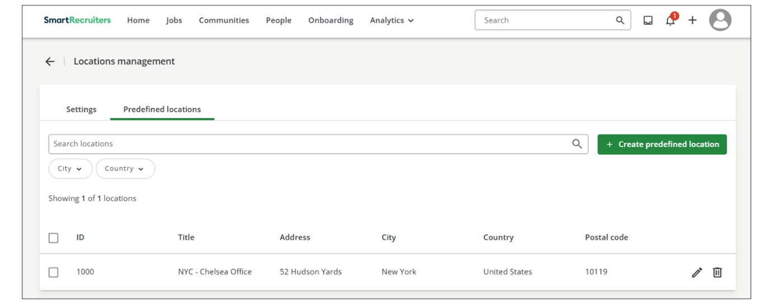
When creating a new predefined location, the interface captures several key data elements to define each location:
- Required Geographical Data: The most essential fields captured are Country and City, which must be selected from a verified, controlled list within the system.
- Detailed Address Information: Users can also record the street address and postal code for precise internal documentation.
- Geospatial Data: To enhance the public job ad, the system allows for the input of latitude and longitude coordinates, enabling the display of an interactive map for the candidate.
- Internal Identifiers: For administrative and system integration purposes, the interface captures internal identifiers that are hidden from the job ad. These include a unique ID (suitable for store or facility codes) and a descriptive Title (such as London Office or Flagship Store).
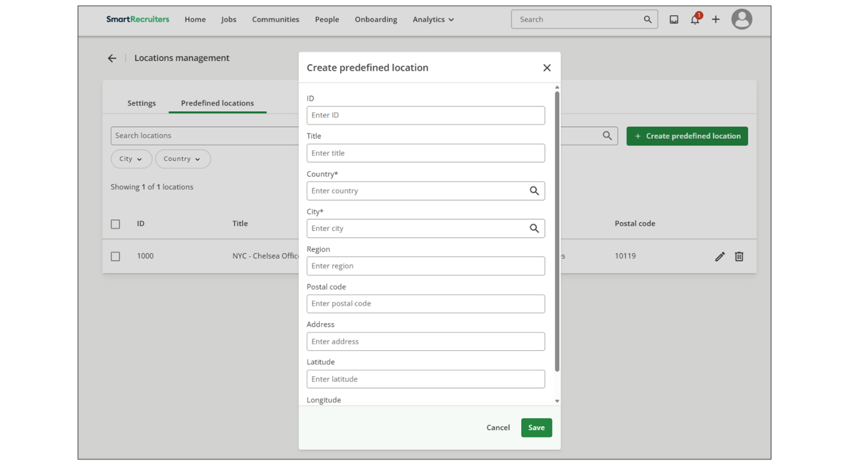
Once predefined locations are created, users will not need to input open text during the job creation process. Instead, users will be able to use a location dropdown to help them select the appropriate location for the job.
When managing predefined locations, you can edit or delete any location using the available icons. However, these changes do not affect active jobs that are already using the location. To apply the updates, those jobs must be manually updated.
Enable Predefined Locations
Admins can enable predefined locations for their environment to standardize job postings.
Steps
- Select User Menu→Settings.
- Select Location management.
- Toggle Enable Predefined Locations to ON.
- Select Save to apply the changes.
Create a Predefined Location
You can create, edit, and manage a list of predefined locations.
Steps
- Navigate to Settings.
- Select Job Locations.
- Navigate to the Predefined Locations tab to view existing locations and search or filter by city or country.
- Select Create Predefined Location to open the data entry form.
- Enter the required Country and City by typing the names and selecting them from the system list.
- Populate optional internal fields like ID (for store and location codes), and Title (for a descriptive name like Flagship Store).
Note
These fields are for internal use only and won't appear on the job ad.
- Optionally enter the postal code and street address.
- Input latitude and longitude if you intend to display a map on the advertisement.
- Select Save.
Watch this video for more information about managing job locations.
This video is for demonstration purposes. Any references made in this video to previous or later videos in this course (including titles, numbers, links, or sequence) may differ from the current course structure. Additionally, some functionalities shown may have evolved over time due to ongoing enhancements or business decisions.
Summary
- SmartRecruiters offers three job location settings: street address, city-only, and predefined locations.
- Administrators can configure these settings in the Locations Management section under Administration.
- Predefined locations streamline job creation, reduce manual data entry, and improve job location consistency, especially for businesses with multiple locations.
In this video, we're going to
take a look at job locations management in SmartRecruiters. In the job creation process, administrators can
control how the job location is added by selecting the
appropriate job location setting. There are currently three settings.
The first is inputting the street address, which uses Google
API to allow users to type in the job address and then match it to
the Google address in real time. The second option is inputting
only the job location city. This also uses Google API, but only
allows users to type in the city rather than the full street
address. This can be useful when the exact street address isn't
needed, or if it varies by role. The third option is selecting
predefined locations, which consists of a list of locations
managed by the administrator. This option can help
streamline job creation, reduce manual data entry, and improve
job location consistency. This can be especially useful
for businesses operating across multiple job locations. such
as retail stores or hotels. In this system, I currently
have the street address setting configured. So as I start
to type the name of the street where my job is located,
I'm prompted with the address suggestions and then I can
select the correct address. As an administrator, to
change the job location setting, I'm going to
navigate to the Settings page and once there, select the
Locations Management option located under the Administration
section. On the Locations Management page, we'll see
the three location settings. To enable a setting,
click the checkbox next to the preferred setting and
click the Save button. If you want to enable
predefined locations, then you'll need to create
the list of locations, which you can do on the
Predefined Locations tab. On the Predefined Locations page, you'll see a list of all of
your current locations. You also have the ability to search
for a particular location using the search bar, or you can filter
your locations by city or country. To create a new location,
click the Create predefined location button at the
top right of the page. On the location creation window,
you'll see a number of location fields you can fill out and the only
required fields are country and city. You can enter store or location IDs
in the ID field and in the title field, you can enter the name of
a location such as London office or flagship store and these fields
will not appear on the job ad. In the country and city fields, you
can begin typing the name of the country or city and then select
the correct location from the list. You can then enter a postal
code and street address. And if you want to have a map on
the job ad that displays the job location, then you can enter
in the location's latitude and longitude. You can click the Save
button to add the location, but for now I'm just going to go back to
the Locations Management page. You can edit or delete locations by
clicking the edit or delete icons, and I just want to note that editing
or deleting a location will not affect any active jobs that have
that location. If you edit or delete a location that is being used on
an active job the job would keep that location until you edit the
job and choose a different location. I'm going to change the location
setting to Predefined locations and then show you what this will
look like when users create a job. So if Predefined locations are
enabled, when the user clicks on the location field while creating
a job, they will be presented with a drop-down list of the
predefined locations to choose from, rather than being able
to freely type in a location. Location management gives you control over how job locations are entered. Whether that's typing a full
address, entering just a city, or choosing from a predefined
list, choose the method that works best for your hiring
processes and make job creation faster, more accurate and more
consistent across your team.
Managing Job Fields In Bulk
Objective
After completing this lesson, you will be able to manage job field values and dependencies at scale using the Job Field Bulk Download and Upload feature.
Job Fields and Dependency Modification in Bulk
The SmartRecruiters Job Field Bulk Download & Upload feature makes it easy to manage job fields at scale. It lets you download all active and archived job field values and dependencies into a CSV file, update them, and upload the changes back into the system. This is especially helpful for large organizations that need to efficiently update job field values and their dependencies.
The Job Field Bulk Download & Upload feature allows users with Job Field Management access to perform the following actions:
- Download a CSV file containing all active and archived Job Field Values.
- Download a CSV file containing all Job Field Dependency relationships.
- Upload a CSV file to create, edit, activate or archive Job Field Values.
- Upload a CSV file to establish Job Field Dependency relationships.
- View the status and details of past uploads for both Values and Dependencies.
- View success and error messages for uploaded Values and Dependencies files.
When to Use Bulk Management
While manual updates are suitable for small changes, the bulk upload feature is ideal when:
- You need to update numerous job fields at once.
- You need to manage complex dependency relationships.
- You want to ensure consistency across a large number of job postings.
Note
Make sure there are no duplicate values in the file. SmartRecruiters will return an error if a picklist contains duplicate values, even if those values are archived. Best practice is to remove any values that already exist in SmartRecruiters from the upload file.
Modify Job Field Values in Bulk
Steps
- Navigate to Settings.
- Select Job Fields.
- Select Bulk Upload within the Job Fields page.
- Select Download Values to download your current job fields. The downloaded job values CSV file includes columns for:
  - Type of field: Whether it's an org or job field.
  - Field ID: The unique identifier for the field.
  - Field label: The display name of the field.
  - Value ID: The unique identifier for each value within the field.
  - Value labels: The display name of each value.
  - Archived: Indicates whether a field is active (false) or archived (true).
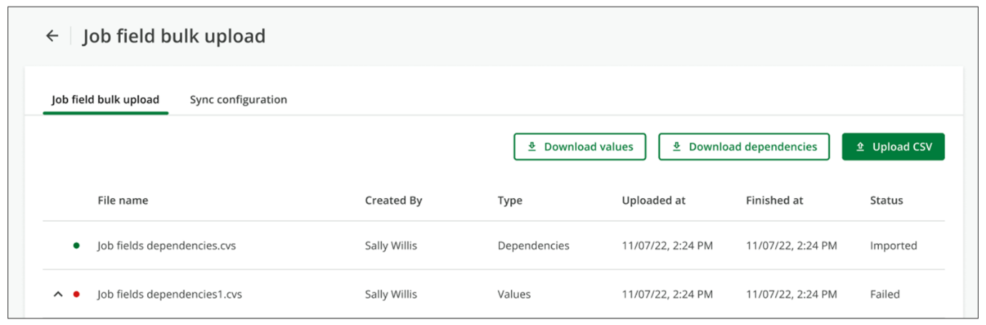
- Open the CSV file.
- Add or edit Job Field Values in the CSV file.
- Save your file in CSV format.
- Select Upload CSV.
- Choose or drop in the file you wish to import.
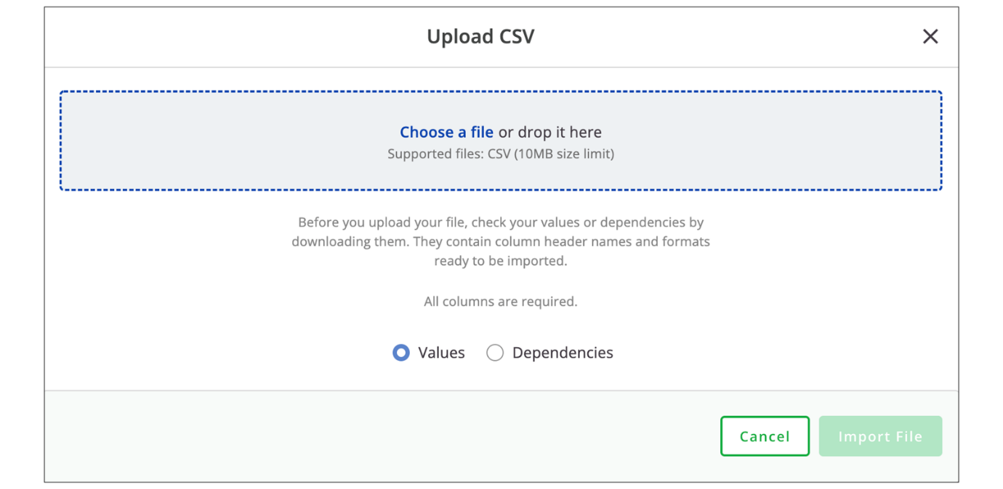
- Select Values.
- Select Import File to confirm.
Note
This tool utilizes a selective File Drop-off functionality for values. For every field with values listed in the CSV file, any missing values will be archived. If a field and its values are omitted from the CSV, they will not be archived. Empty files will not lead to archived values.
Modify Job Field Dependencies in Bulk
Steps
- Navigate to Settings.
- Select Job Fields.
- Select Bulk Upload.
- Select Download Dependencies.
Note
The downloaded dependencies CSV file includes columns for the parent field and value, and the child field and value. These columns define how job field values are related.
- Open the CSV file.
- Add or edit Job Field Dependencies in the CSV file.
- Save the file as a CSV.
- Select Upload CSV.
- Choose the file you wish to import.
- Select Dependencies to indicate the file type.
- Select Import File to confirm.
Note
This tool utilizes a selective File Drop-off functionality for dependencies. For every parent field listed in the CSV, dependency relationships will be removed when a child field is missing.
Best Practices for Using the Bulk Import Feature
- Make sure your job fields exist before managing the Values & Dependencies.
- New job fields are not active until you add at least one value.
- Be sure you have established the overall dependency structure for your job fields.
- Please check that you’re in the correct SmartRecruiters environment (production vs sandbox).
- The tool stops the upload at the first error encountered. If your file contains an error, some values and dependencies may not get updated.
- Make sure your ValueIDs are unique to avoid duplicate errors.
- It is recommended to manage values first and then dependencies.
- Archiving values and removing dependencies can impact downstream values and dependencies, as well as reporting and jobs.
- When opening your CSV in an editor, do not select Convert text to numbers, dates, and formulas, as this may corrupt ID values.
- Be sure that you are using commas as delimiters/separators. Sometimes office tools convert to semicolons, resulting in incorrect formatting.
- Office tools will sometimes delete leading zeros (0) in numbers. To be sure your leading zeroes don’t get dropped, format in plain text.
- Watch out for special text characters. This tool uses UTF-8 with 1 byte per character; other characters may cause errors.
- If your file size is larger than 14MB, try splitting it up.
- Test the tool for a small amount of data before doing large numbers of creations, edits, or deactivations.
Job Field Bulk Download and Upload Tool Limitations and Restrictions
Job Field Bulk Download & Upload does not perform the following actions:
- Create entirely new job fields; it can only create values within job fields that already exist and have at least one value.
- Establish dependency relationships among job fields.
- Download only selected field values or dependencies; the tool exports everything.
- Create or edit special job fields (org fields) for Country/Region.
- Create, edit, or download free text (free-entry) fields; the tool only works for Single Select (dropdown list) fields.
- Edit field IDs and value IDs, and field types; only labels and archived status may be changed.
- Create new custom ValueIDs; new ValueIDs are automatically replaced by randomly generated IDs by SmartRecruiters. If clients want their values ID to match their HRIS IDs, then the API should be used for having custom Values IDs and field names IDs.
- Manage duplicated job field values.
- Show errors for each row of data; only displays the first error encountered.
Watch this video for more information about downloading and uploading job fields in bulk.
This video is for demonstration purposes. Any references made in this video to previous or later videos in this course (including titles, numbers, links, or sequence) may differ from the current course structure. Additionally, some functionalities shown may have evolved over time due to ongoing enhancements or business decisions.
Summary
- The Bulk Upload & Download feature in SmartRecruiters allows for efficient management of job fields and their dependencies at scale.
- Downloading the existing job fields and dependencies as a CSV is crucial before making any modifications to ensure the correct IDs are used.
- Modifications can be made directly in the CSV file, including adding new values and defining dependency relationships.
- Uploading the modified CSV back into SmartRecruiters updates the job fields and dependencies in the system.
- The bulk management feature is most beneficial for large organizations needing to make widespread changes to their job fields.
In this video, we're going to
be looking at the job field bulk download and upload
feature in SmartRecruiters. The bulk upload and download
feature allows you to download all of your active and
archived job field values and dependencies, as well as upload
any changes you need to make to your job field values or
the dependency relationships. The download feature is great
if you need to report on your current job fields and you need
a way to be able to download them into a CSV. And the upload
feature is meant to help large organizations that need to manage
or edit their job field values and dependencies at scale. To
use the bulk upload and download feature, click the Bulk Manage
button on the Job Fields page. Here you'll see any prior
uploads that you've done in the past, whether it's job
values or the dependencies. To download your job fields, just
click the Download Values button, or if you want to download
all of your current dependency relationships you can click the
download dependencies button here. I'm going to click
download values and you'll see that my job values
download in a CSV file. The columns on the download
include the type of field, whether org or job field, the
field ID, the field label, the value ID, and all the
value labels within one field. The archived column tells you
whether a field is currently archived or not. If it says
false that means it is an active value and if it were to say true
that means it's been archived. Similarly when I download the
dependencies I'm going to get a similar looking CSV file
but here the parent field and parent values are first in the
spreadsheet and then all of the child values are on the
left side of the spreadsheet. If you're looking to upload a CSV
with changes to your job field values or dependencies, you'll first want
to download your fields as I just did and then make a copy of this
csv as it will allow you to have the correct field ids and value ids, and
if these are incorrect then your upload can fail. For example, if I wanted
to add a new office location us city to my office locations job field,
I can do that manually on the job fields page or I can do it through
the spreadsheet upload. So I've saved a copy of this job field values
list so I have all of my field IDs and value IDs there and I'm going to
open my copy. Then in this scenario I'm going to be adding an office
location to my Massachusetts offices. So if I go down here to office location city I'm going to
be adding a new Massachusetts office and I'm going to keep all of the
field information here the same. I'm not going have a value
ID for this new value because it's new, but I am
going to put in the label. And then I do not want this
archived. I'm going to save this. And now I'm going to come back to SmartRecruiters and click Upload CSV. It's going to ask me whether
I'm uploading a values or dependencies spreadsheet.
I'm going to do values in this case. I'm going
to drag my CSV doc here. And now if I go back to my
job field values the new value should be in the
office location city field. And hybris my new field here. So now that I have my new value
under my office locations for Springfield I want to create a
dependency where if the user creating the job chooses Massachusetts as the
state I want to add that Springfield city to pop up along with the
other Massachusetts cities. Again you can do this manually through
the job fields page but this is an example of how to do it if you
were to do it through the upload. So since I have a new value I
want to download my values again because that's where I'm going
to get the value ID for my new city and I'm also going to
download my dependencies again. I'm going to open up the fields first because I want to grab that value ID from my new city so for
Springfield it is here. Now I'm going to open up
my dependencies and office location is at the top so
I'm going to want this to be under Massachusetts so
I'm going to add a row here and I'm going to copy that
value since this is going to be the child I'm going
to copy it under the child value ID column and then I'm
going to write Springfield. The rest of it is the same
because you're keeping the parent field and the
child field of office location the same. So you just can
copy this up here, and then I'm going to save this. So now that it's saved,
I'm going to upload my CSV. This is going to be dependencies,
and I'm just going to drag it over. Now that that's loaded, I can
go back, and I should see the dependencies show up under the
office locations U.S. city field. So now if I click on
Massachusetts, you'll see Springfield is now chosen under here. Again, if you do not have a lot of
job fields, it's recommended that you manually add dependencies or
change fields here. But if you are working in bulk and you have
numerous job fields and you need to update a lot at once, the upload
feature is a great way to be able to do that all at the same time. Thank
you for watching this video on the Job Field Bulk Upload and
Download feature in SmartRecruiters.

Setting Up Job Approvals
Objective
After completing this lesson, you will be able to configure job approval workflows and delegation settings to ensure consistency and compliance in the hiring process.
Job Approvals Setup Process
Job approvals in SmartRecruiters provide a structured way to manage the hiring process by ensuring that the right people review and approve job postings before they are published. Jobs requiring approval cannot be published until all designated approvers have granted permission. Approvers are notified via email and can review job details either directly from the notification or by logging in to the system.
By default, approvers are granted temporary admin access to the job, which can be configured to revert to their standard permissions once the approval is complete. These controls help maintain consistency, compliance, and quality throughout the hiring process.
The approval setup is a two-step process:
- Create the set and choose which jobs it should apply to using the org field values.
- Add the approval chain.
There are three approval chain options:
  - Set up a sequential chain in which approvers receive requests and approve in sequence.
  - Set up a parallel approval chain, in which all approvers receive approval requests at the same time and can approve independently. When configuring a parallel chain, there are two options: all approvers must approve the job, or at least one approver must approve it.
  - Set up an integration approval chain that enables the integration to retrieve and manage approval requests on behalf of the system user.
Administrators define which jobs require approval by assigning a unique combination of org field values to an approval chain. For example, a job approval workflow can be applied only to jobs in a specific country by using the standard Country org field. This org field-based logic applies to all approval chains except integration approval chains, which are not limited by org field combinations.
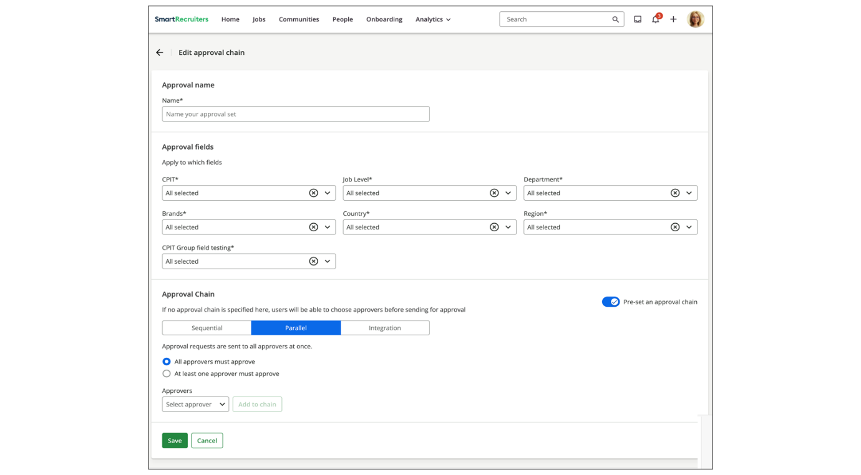
SmartRecruiters notifies approvers in the approval chain via a summary email when a user submits a job for approval during job creation. Approvers can review the job details and approve directly from the email or by logging into SmartRecruiters. Jobs that require approval cannot be published until all designated approvers have approved the job.
Approvers will only see the job on the job list if they are part of the hiring team or have a special user role. As a best practice, approvers should use the summary email to initiate their approval process.
Note
When you make someone an approver on a job, they will always have access to that job, even if they're removed from the hiring team.
Approval Chains
When creating a job, particularly within a department with a configured approval chain, the approval chain option will appear during the job creation process. If a preset approval chain was not configured, you can set one up during job creation. You can choose between sequential or parallel approvals and name the approvers.
Once the approval chain is set, the user can submit the job for approval. Users with access to the job details tab can review the status of the approvers. The status will update as each approver submits their approval, indicated by green checkmarks. Once all approvers have approved the job, it is ready to be published.
Approval chains come in four types:
- Per-job chain: Allows job creators like Hiring Managers and Recruiters the ability to choose approvers for each job. This gives the job creator more flexibility.
- Parallel chain: Allows administrators to designate a pool of approvers in advance.
- Sequential chain: Allows administrators to designate a strict sequence of approvers.
- Integration chain: Allows the administrator to designate that an approval process will be managed by an integration.
Per-job chain
To allow the job creator to choose approvers for each job during job creation, leave Preset an approval chain turned off, and select Save. Job creators can choose their own approvers from the Hiring Team step of the Job Posting wizard.
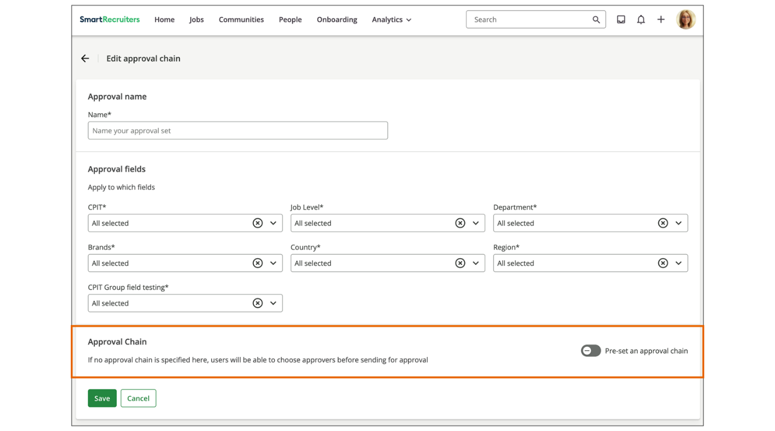
Parallel chain
Create a parallel approval chain to define a pool of approvers in advance while allowing flexibility in how approvals are granted.
In a parallel approval chain:
- All approvers receive approval requests simultaneously.
- Approvers can review and approve independently.
Unlike sequential chains, a parallel chain can be configured so that either all approvers must approve the job or only one approver is required to approve it. In the latter case, the request is approved so long as a single approver gives approval, even if one (or all) other approvers decline.
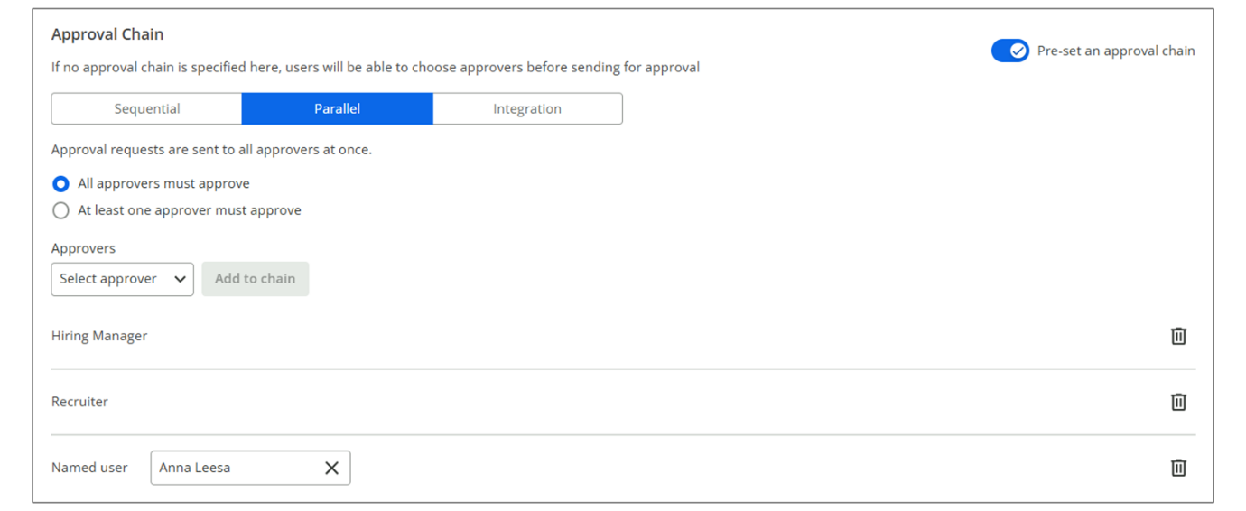
Sequential chain
Use a sequential approval chain when approvals must happen in a specific order. In this setup, each approver receives the approval request only after the previous approver has approved the job. The job cannot be published until every approver has approved it in sequence.
In this example, the Hiring Manager will receive the first approval request. When they approve, the Recruiter will receive a request for approval.
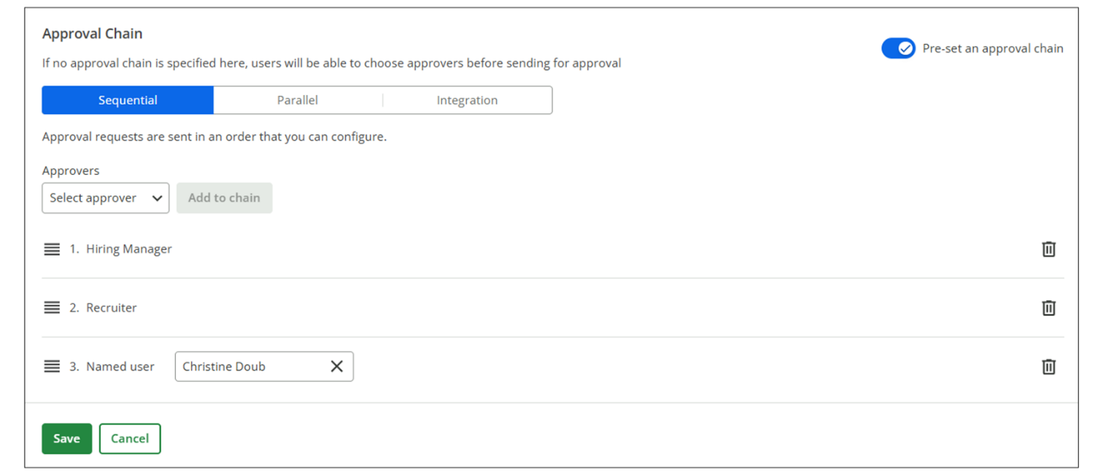
Integration chain
With the introduction of the system user, API credentials are now associated with this role. API credentials can retrieve approvals that belong to the system user and support customers who wish to build an approval integration.
- Admins configuring job approval templates can set an integration as the initial approver in Settings/Admin→Job Approvals.
- The integration returns a list of approvers using business rules from another system, such as a Human Resource Information System (HRIS).
The integration approval process is typically used when the org fields’ logic does not align with the client’s approval requirements.
If the wrong app is selected from the pull-down list, then the approval chain will be created with only this integration user assigned. Since the integration will not populate the approval chain, the job approval will start, but cannot be completed.
If an administrator selects the wrong integration and the approval chain is picked up by an active job, making the correction on the Approval settings page will not automatically re-trigger the approval process. The job will need to be edited, and once done, the integration will run as designed
This integration uses Approval API GET/Approvals.
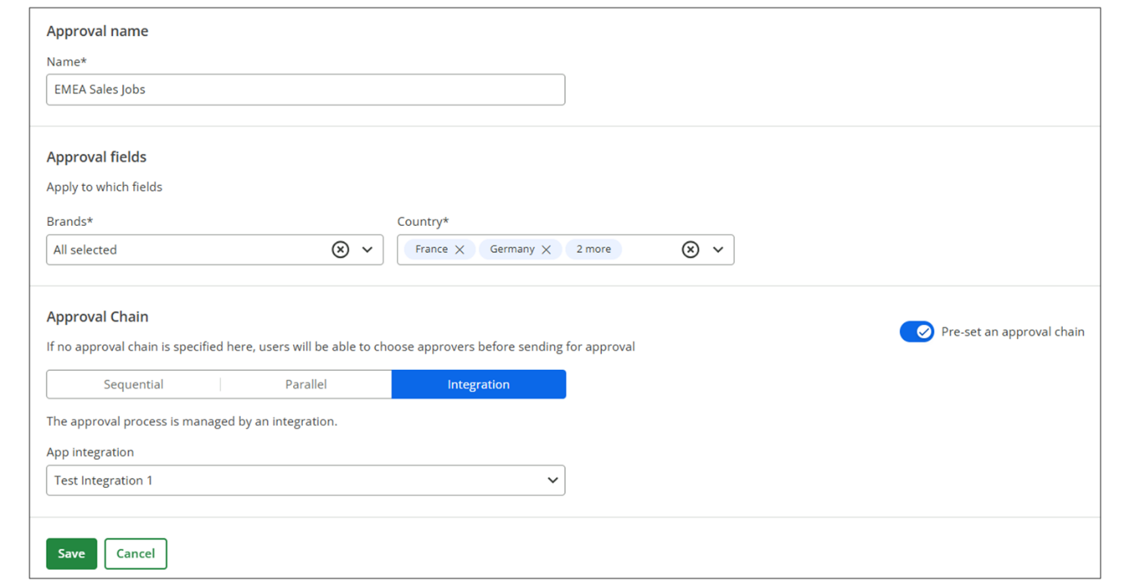
Create a Job Approval Chain
Steps
- Navigate to Settings.
- Select Job Approvals from the Configuration section.
- Select New Chain on the Job Approvals page.
- Provide the approval with a name.
- Select the Org Field values to assign the approval chain to a set of jobs.
  - To set up a global chain that applies to all jobs, leave the field set to All for each field in the list.
  - To set up a chain that applies to only some jobs, choose One or More values for each org field.
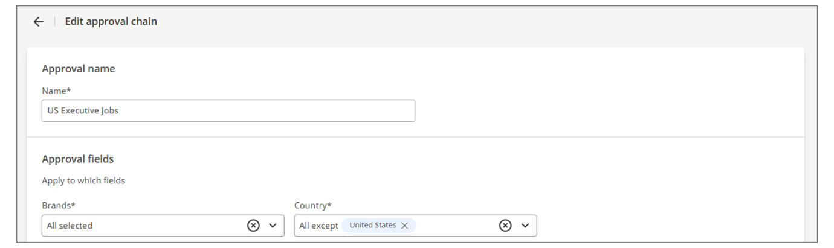
- Enable the Pre-set an approval chain setting to configure a predefined approval workflow.
Note
If this setting is disabled, users can choose approvers during the job creation process before sending for approval.
- Select the approval chain type (Sequential, Parallel, or Integration).
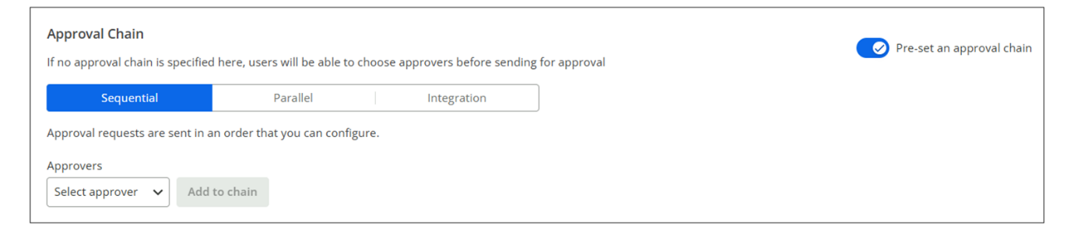
- Select the approvers to add to the chain.
  - Select a Hiring Team role to be added to the approval chain.
  - Select a Named user to add a specific user directly to the approval chain. This user does not have to be on the hiring team.
  - Select Any user to allow the addition of a user manually to the chain. This user does not need to be on the hiring team; any user with system access can be used.
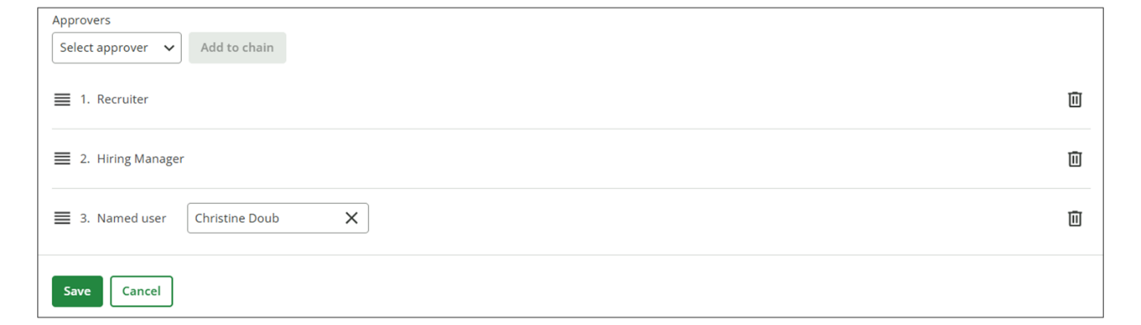
- Select Save.
- Return to the Job Approvals page.
- Set Toggle to Active.
Note
Approvals chains are not activated immediately, so make sure to toggle the set to Active.
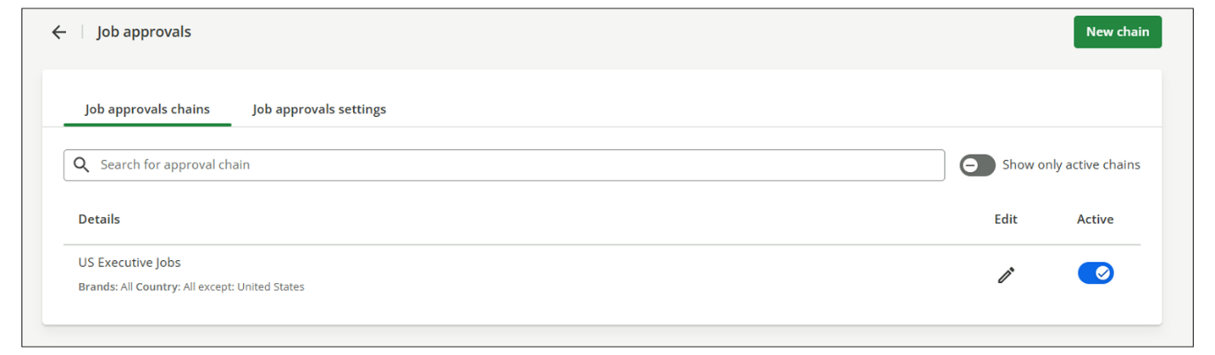
Watch this video for more information about admin job approvals.
This video is for demonstration purposes. Any references made in this video to previous or later videos in this course (including titles, numbers, links, or sequence) may differ from the current course structure. Additionally, some functionalities shown may have evolved over time due to ongoing enhancements or business decisions.
Approval Settings
You can also edit job approval settings to further customize the approval process. These settings can be managed in the Job Approval Settings tab within the Job Approvals page.
These settings include:
- Removing Approver's Access: Determine whether approvers retain access to the job after it has been approved.
Note
By default, job approvers receive full admin access to a job even if they aren’t on the hiring team. If the Job Approval Settings toggle is enabled, this admin access is temporary and is removed immediately after they approve the job. Their access then reverts to their standard role permissions, which may be limited or none if they lack broader rights.
- Delegating Approvals: Allow approvers to delegate their approval to another user.
- Authentication: Require users to log in to SmartRecruiters to approve the job.
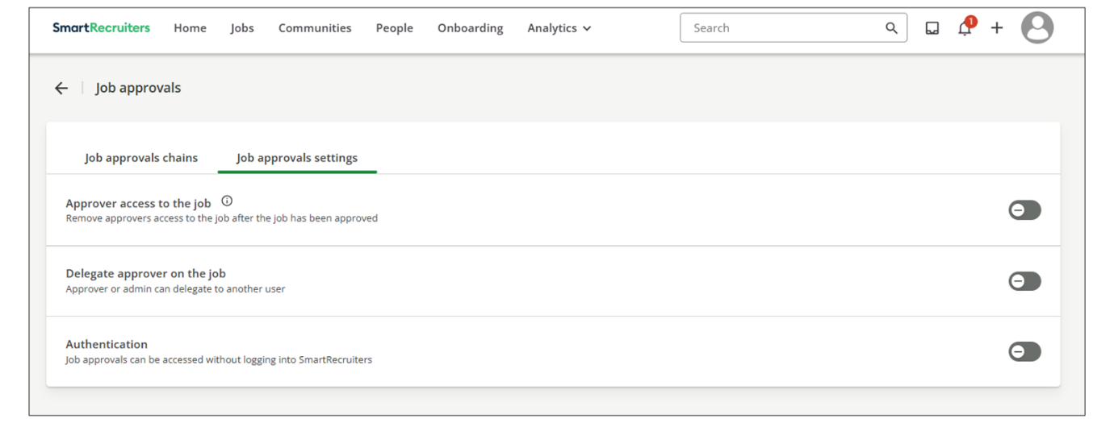
Job Approval Delegation
The Delegate Approvals ​feature enhances the job approval process by allowing users to select a delegated approver to step in while they are out of office, or for an admin to delegate an approval from one user to another for a specific job.
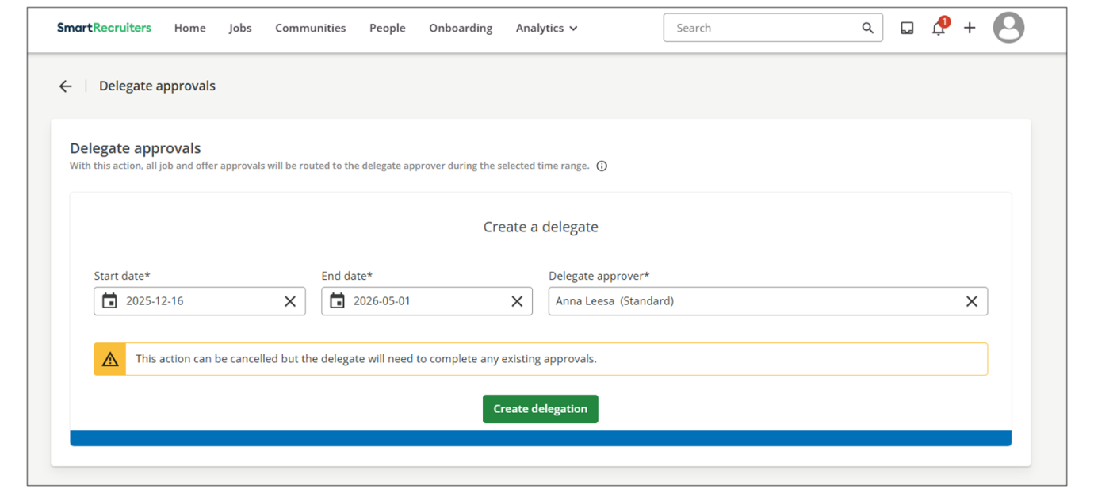
The Delegate Approvals feature adds significant capability to the job approvals feature set. There are two primary use cases.
- Allowing a user (user A) to select a delegated approver (user B) to fill in while user A is out of the office. With this use case, user A selects a specific duration (date range) for the delegation to be enforced. During this time, all job approvals intended for user A are routed to user B.
- Allowing an Administrator to delegate a specific job from one user to another. This does not allow the admin to set a date range. This approach would be used if user A is already out of the office.
Activate Delegate Approvals
Steps
- Navigate to Settings.
- Select Job Approvals within the Configuration section.
- Select the Job Approval Settings tab.
- Enable the Delegate approver on the job switch.
Watch the video below for more information about job and offer approval delegation.
This video is for demonstration purposes. Any references made in this video to previous or later videos in this course (including titles, numbers, links, or sequence) may differ from the current course structure. Additionally, some functionalities shown may have evolved over time due to ongoing enhancements or business decisions.
Review and Approve a Job
When you are assigned as an approver for a new job, SmartRecruiters will email you when someone submits a job for approval.
Steps
- Review the email and select Review in Job. Alternatively, you can access the job on the right side of the screen under Jobs tab.
- Select Approve to immediately approve the request and go to the job’s profile, or select View Details to go to the job’s profile and either approve or decline the request.
- Resubmit the job for approval if you need to change your decision after submitting it.
Note
The job can be posted only once it has been approved by all designated approvers. After approval, the job advertisement can be updated without triggering a new approval.
Resend a Rejected Job Approval
To send a job for approval after it was rejected:
Steps
- Navigate to the Jobs list page.
- Locate the job for which you want to resend the approval.
- Navigate to the Job Details tab.
- Scroll to the Position details.
- Select the pencil icon to edit the details.
- Update the Target start date field.
Summary
- Job approvals in SmartRecruiters provide a structured process for managing hiring by ensuring job postings are reviewed and approved before publication.
- Approval chains can be configured as parallel, sequential, per-job, or integrated to match different organizational needs.
- Administrators can assign approval chains to specific jobs based on organizational fields, ensuring the correct workflow is applied.
- SmartRecruiters notifies approvers of pending approvals, and jobs cannot be published until all required approvals are obtained.
- Job approval settings allow for customization, including removing approver access post-approval and delegating approvals to other users.
In this video, we're gonna review
the option to delegate approvals. The delegate approvals feature
adds significant capability to both our job and offer
approvals feature set. And there are two primary use cases.
The first is allowing a user to select a delegated approver to fill
in while that user is out of office. And the second allows an
admin to delegate an approval from one user to another
on a specific job or offer. To turn on delegate approvals,
we'll wanna go into that approval setting. To activate
the Delegate Approval setting, we'll first need to go into
our Settings Admin page, and you can find this either
in Job or Offer Approvals. Once in the Job Approval
Chain setting, you'll see under Job Approval
Settings, there's an additional setting to
Delegate Approver on the job. We'll go ahead and have this toggled on. Earlier, we reviewed there's
two options for delegating approvals. We'll go ahead and review
the option where the admin can choose one user on a job and
assign an approval to another. As you can see, we have a job
that's currently pending approval. I'll go ahead and select
Betty Smith, as I know she won't be available, and
select the delegate option. I can then choose the delegate. Once I confirm, that user's
name will update in the approval list, and Harrison
will now be able to delegate the approval on behalf of
Betty. The other option you have is to create a delegation
for a period of time. Again, with the example
that someone may be out of the office over
an extended period. On the homepage, which is accessed
by clicking on the SmartRecruiters icon, you'll see on the right
side the option for delegation. If you click on here, you
can create a delegation. You can select the start and end
date from when you'll be out. Let's say I'll be out from
Monday the 5th until the 16th. And anytime that you're listed as
an approver, you can delegate a specific approver you want all of
your approvals to be routed to. Once I select the user, you
can create the delegation. Now this delegation is
active and will remain active from September 5th through
the 16th or until I end it. Hi, in this video, we're
gonna review job approvals. Job approvals ensure the right amount of oversight in your hiring process. You can set up a single approval
process for an entire company or multiple processes for jobs for
different brands, departments, locations, and so on. Within the Settings
admin panel, you will go under Configuration, Job approvals. Now that
we're in the job approval setting, let's review editing our default chain, which is the existing chain we see here. I'll go ahead and click on the edit icon. As with many features in SmartRecruiters, admins can assign approvals to specific groups of jobs by
selecting a set of values for the company's active org fields. SmartRecruiters applies the approval chain to any jobs that have the same set
of values for these org fields. If I wanted to apply this
specific approval chain to a certain job under department,
I can go ahead and do that. I can save it or if I wanted to
continue to edit I can do that as well. When it comes to the actual
approval chain itself, if you don't wish to edit anything ,you'll
see here, that if no approval chain is specified, users will be
able to choose approvers before sending the approval. This will be
done in the job creation process. However, if I wish to set an
approval chain I can click here. I'm now presented with approval
options for sequential and parallel. There's also an
option for integration as well. Sequential means that approval
requests are sent in the order that you can configure,
and parallel approvals mean that the requests are
sent to all approvers at once. I can click down below and
select any type of user, so I can have a named user, any user as
part of the hiring team, or make it so the approval chain pulls
hiring manager, recruiter, executive coordinator, as they
come from the hiring team itself. Once I'm satisfied with the
configuration, I can save. Once saved, I can activate the approval
chain, and now I expect any time a job to be opened under
the department Artist Relations, that job will then have this default
approval chain set up. There's also an option to edit job
approval settings. The different job approval settings listed are
the ability to remove approver's access to the job after a job
has been approved. Since this is off, the approver is going to
maintain access to the job even after the job has been approved.
You can delegate an approver on the job, meaning that you can
move the approval to another user. And there's also settings regarding
authentication, which means if this is turned on, users
don't have to log into Smart Recruiters to approve the job.
I've gone ahead and started creating a job. This job happens
to be under that same artist relations department. So as you
can see here on the third page of the job creation, we're met
with the approval chain option. In the setting, I didn't preset an
approval chain, so I can do that here during job creation. I'm
going to make this a sequential approval and name the approver. Now
that I've set my approval chain, I can submit for approval. To
review the status of the approval, users that have access to
the Job Details tab will be able to review the
status of the approvers. As you can see here, this job is
still pending approval, but once every approver on the chain submits
their approval, these will update to green checkmarks and your job
will be ready to publish. Thank you.

